Lancaster Seventh-Day Adventist Church
A House of Prayer for All People
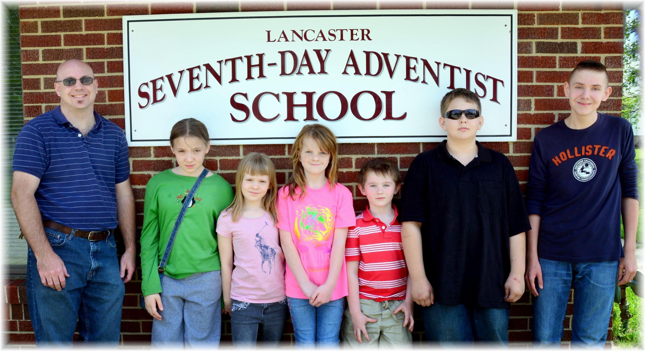
Lancaster SDA Online School ~~ May 2015

