Lancaster Seventh-Day Adventist Church
A House of Prayer for All People
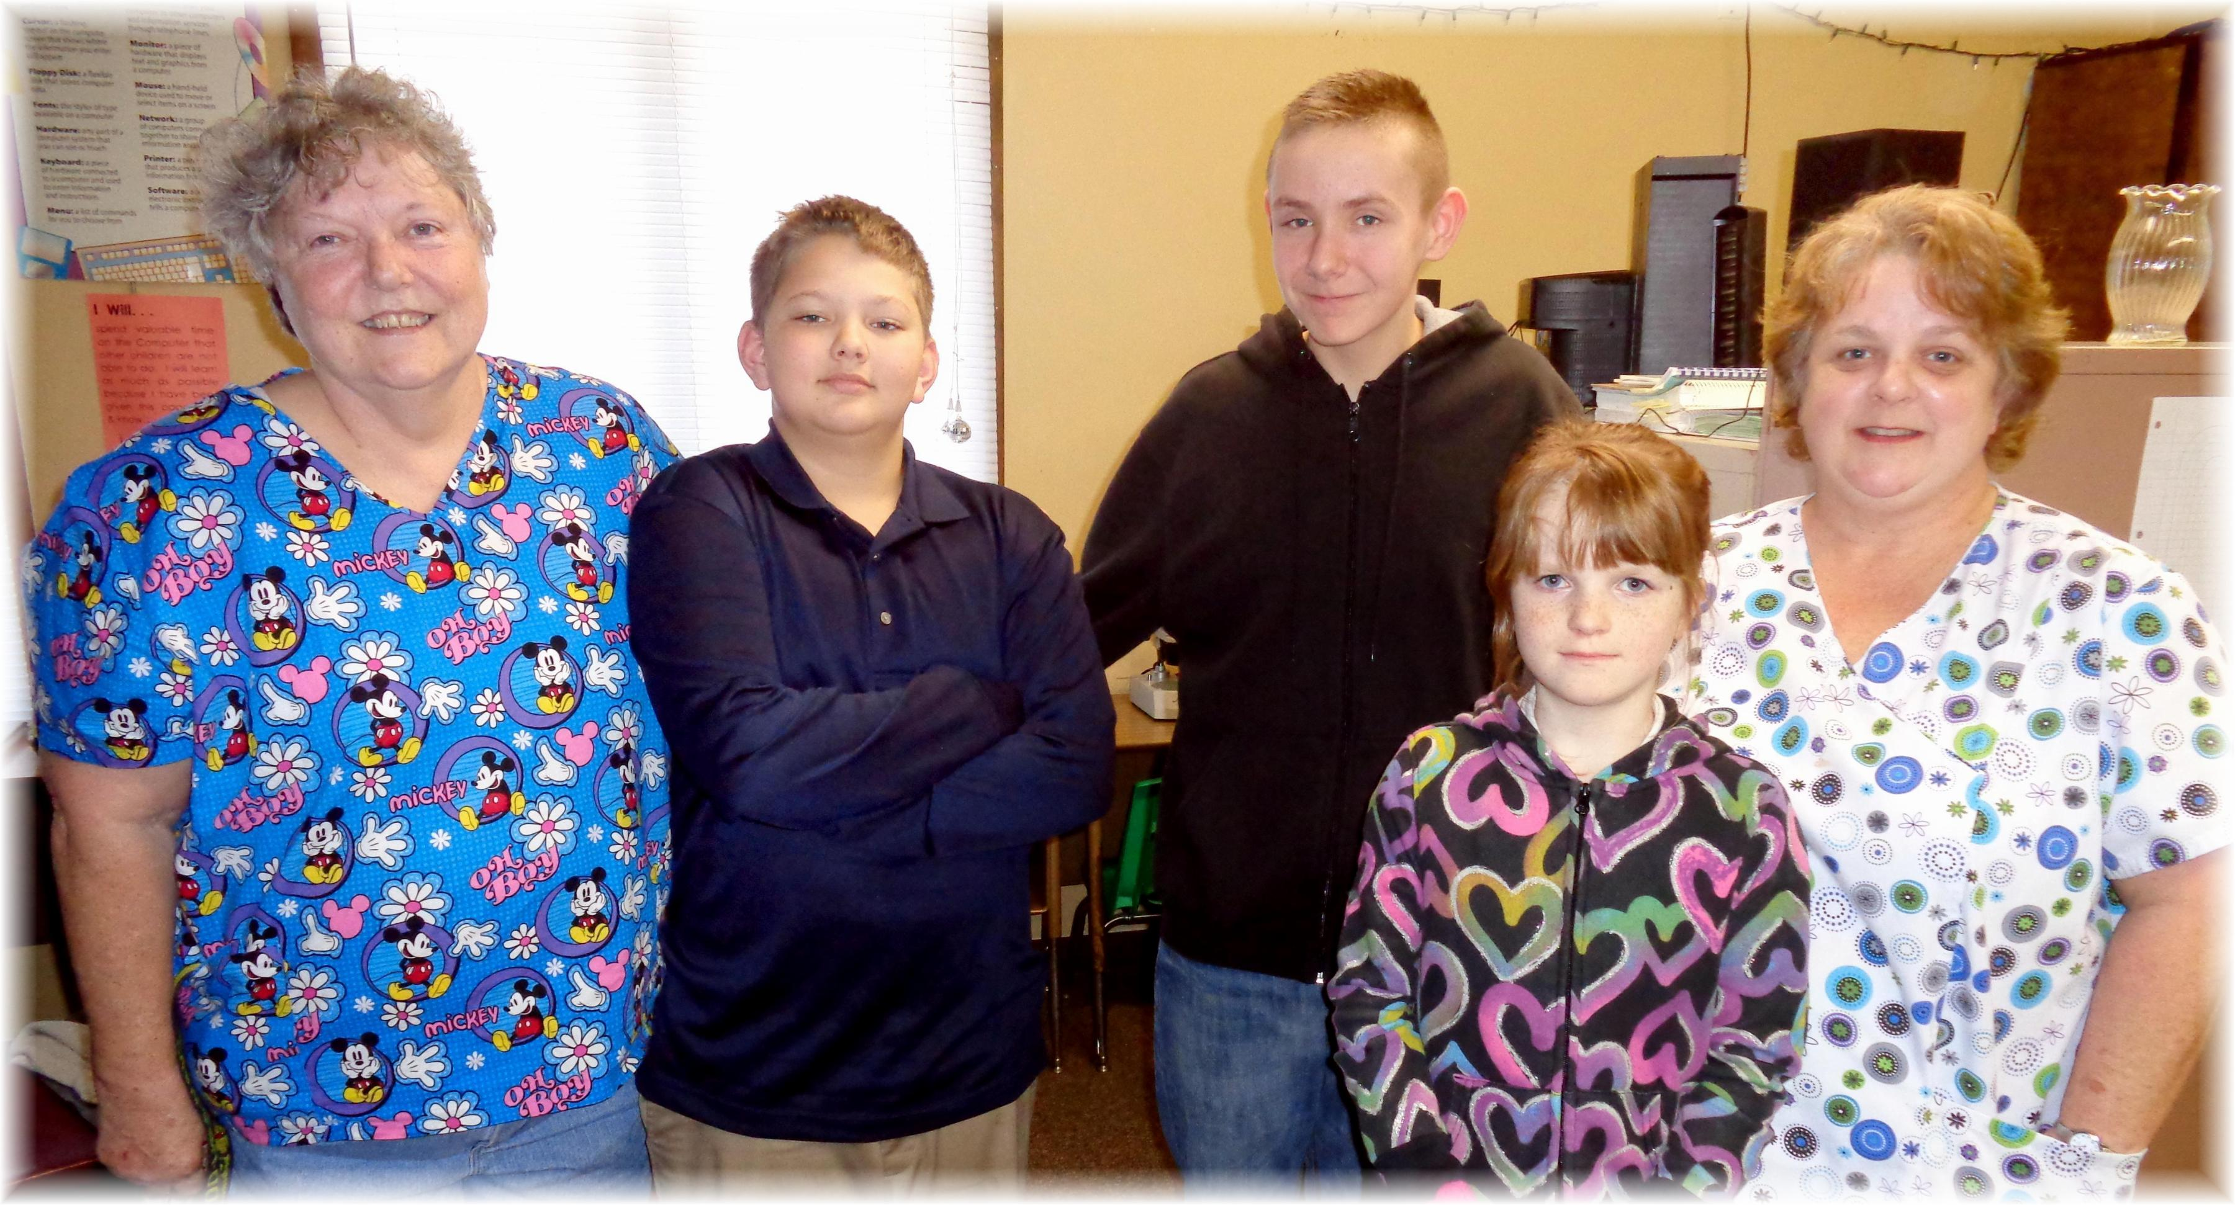
Ms. B., Brave, David, Rachael, Miss Dever
Lancaster SDA Online School ~~ 2014-2015

