Lancaster
Seventh-Day Adventist Church
A House of Prayer for All People

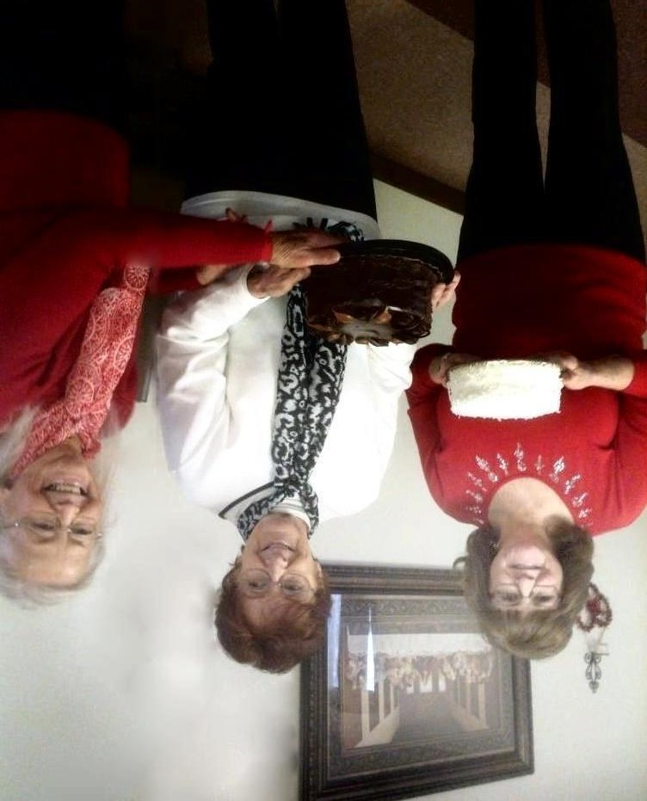
Linda, Alice, and Sharon
February Birthdays - 2018

