Lancaster
Seventh-Day Adventist Church
A House of Prayer for All People

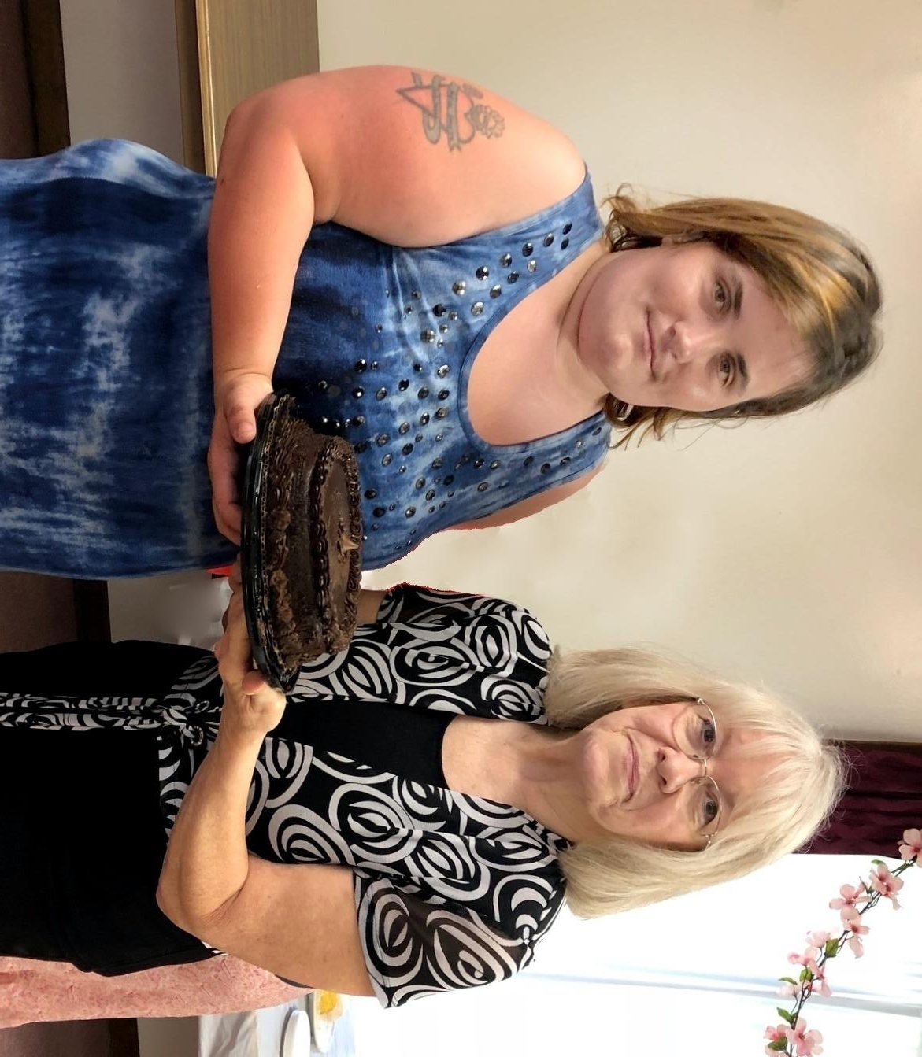

Becky Donna
June Birthdays ~ 2018

