Lancaster Seventh-Day Adventist Church
A House of Prayer for All People

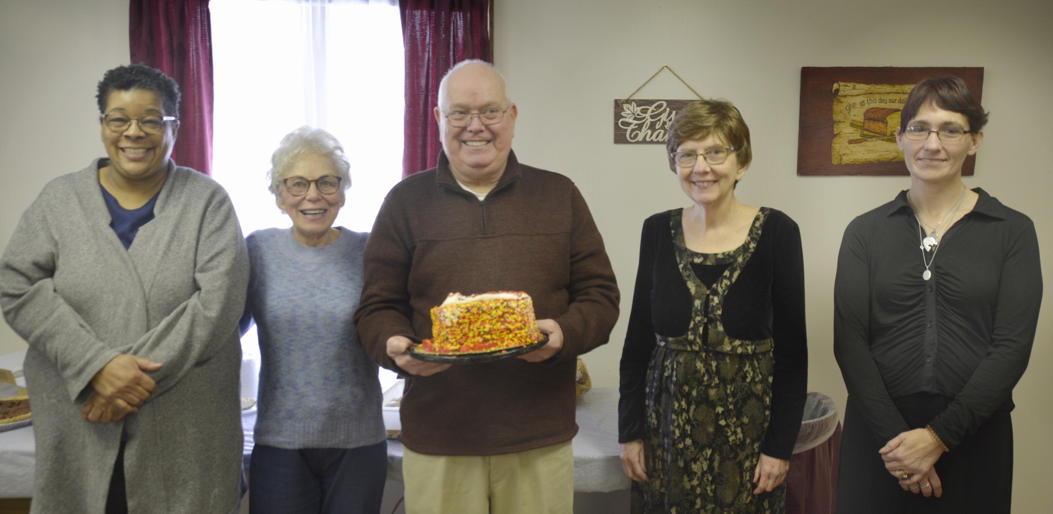
December: Arlene, Barbara, Darrell January: Bonnie, Jessica
December 2021 and January 2022 ~ Birthdays

