Lancaster Seventh-Day Adventist Church
A House of Prayer for All People

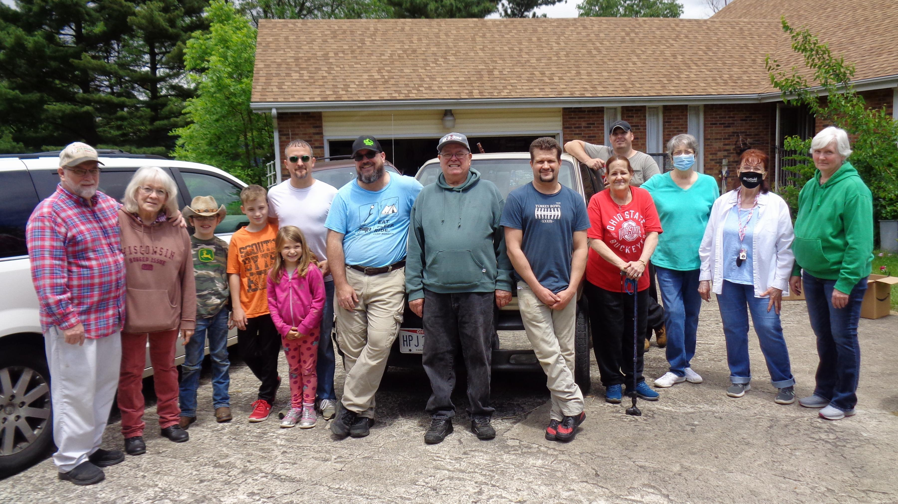
Good Neighbor Thrift Store Donation Pickup ~ 5-30-21

