Lancaster Seventh-Day Adventist Church
A House of Prayer for All People

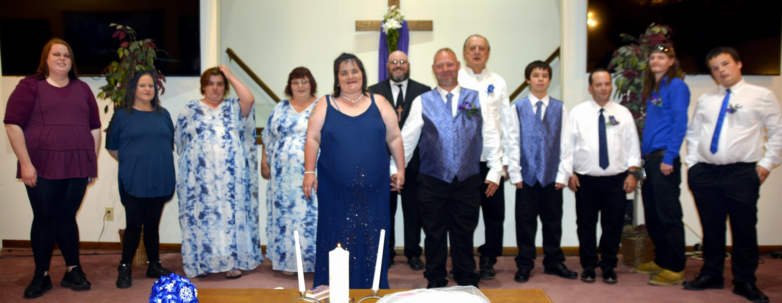

Becky & John Husk Wedding ~ 5-4-21

