Lancaster Seventh-Day Adventist Church
A House of Prayer for All People

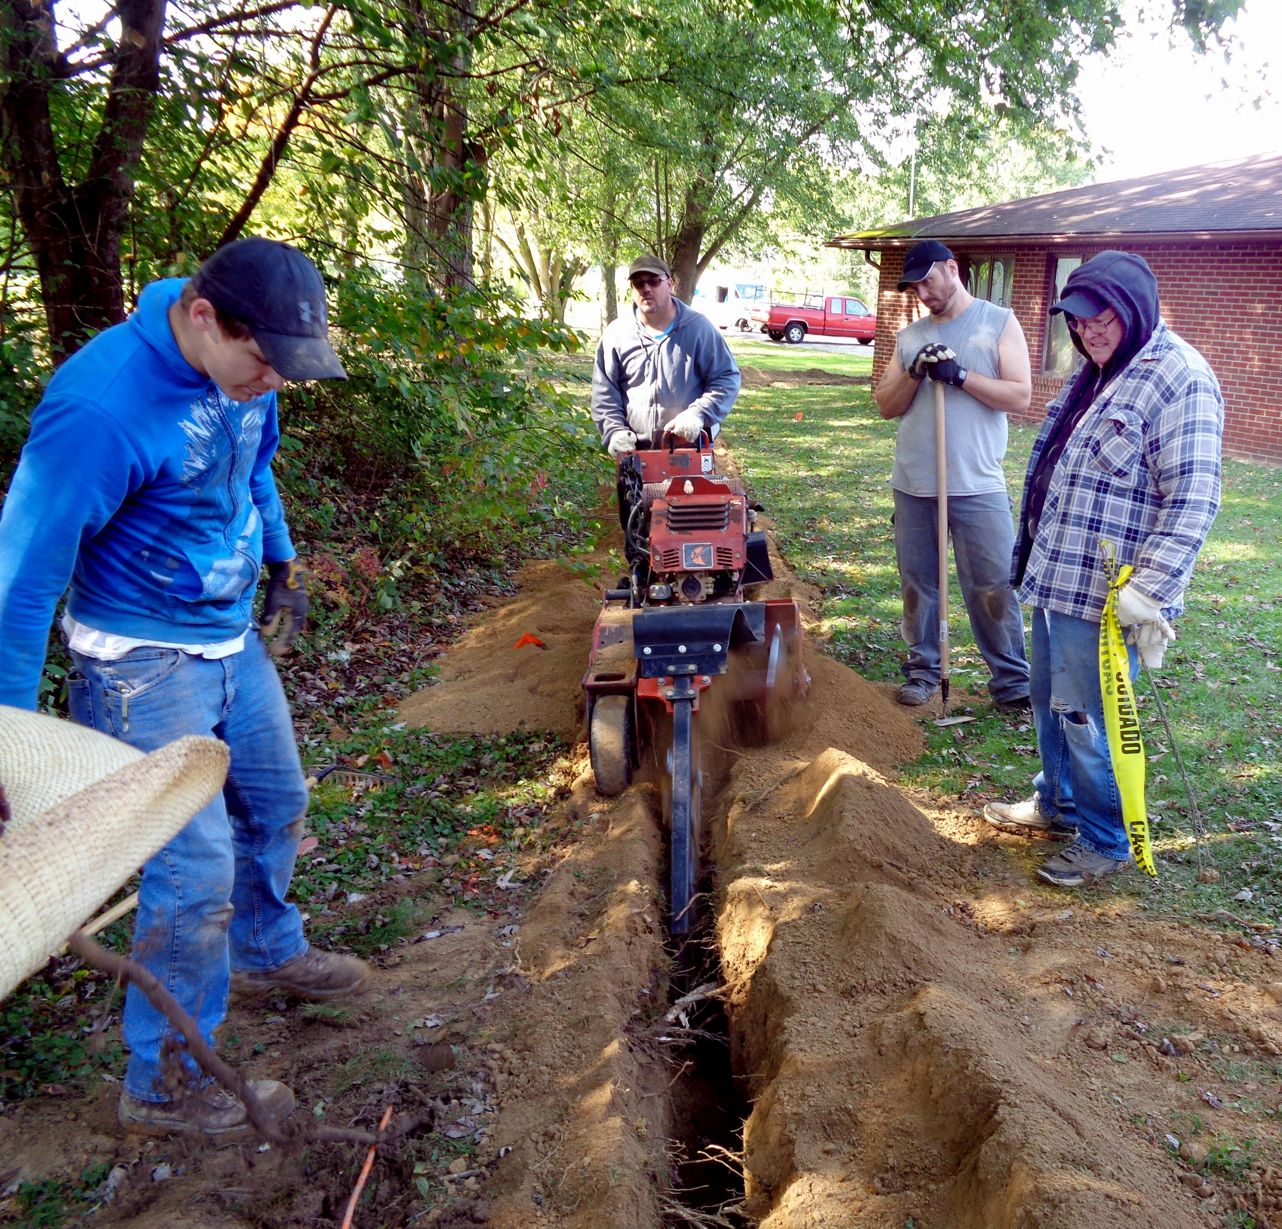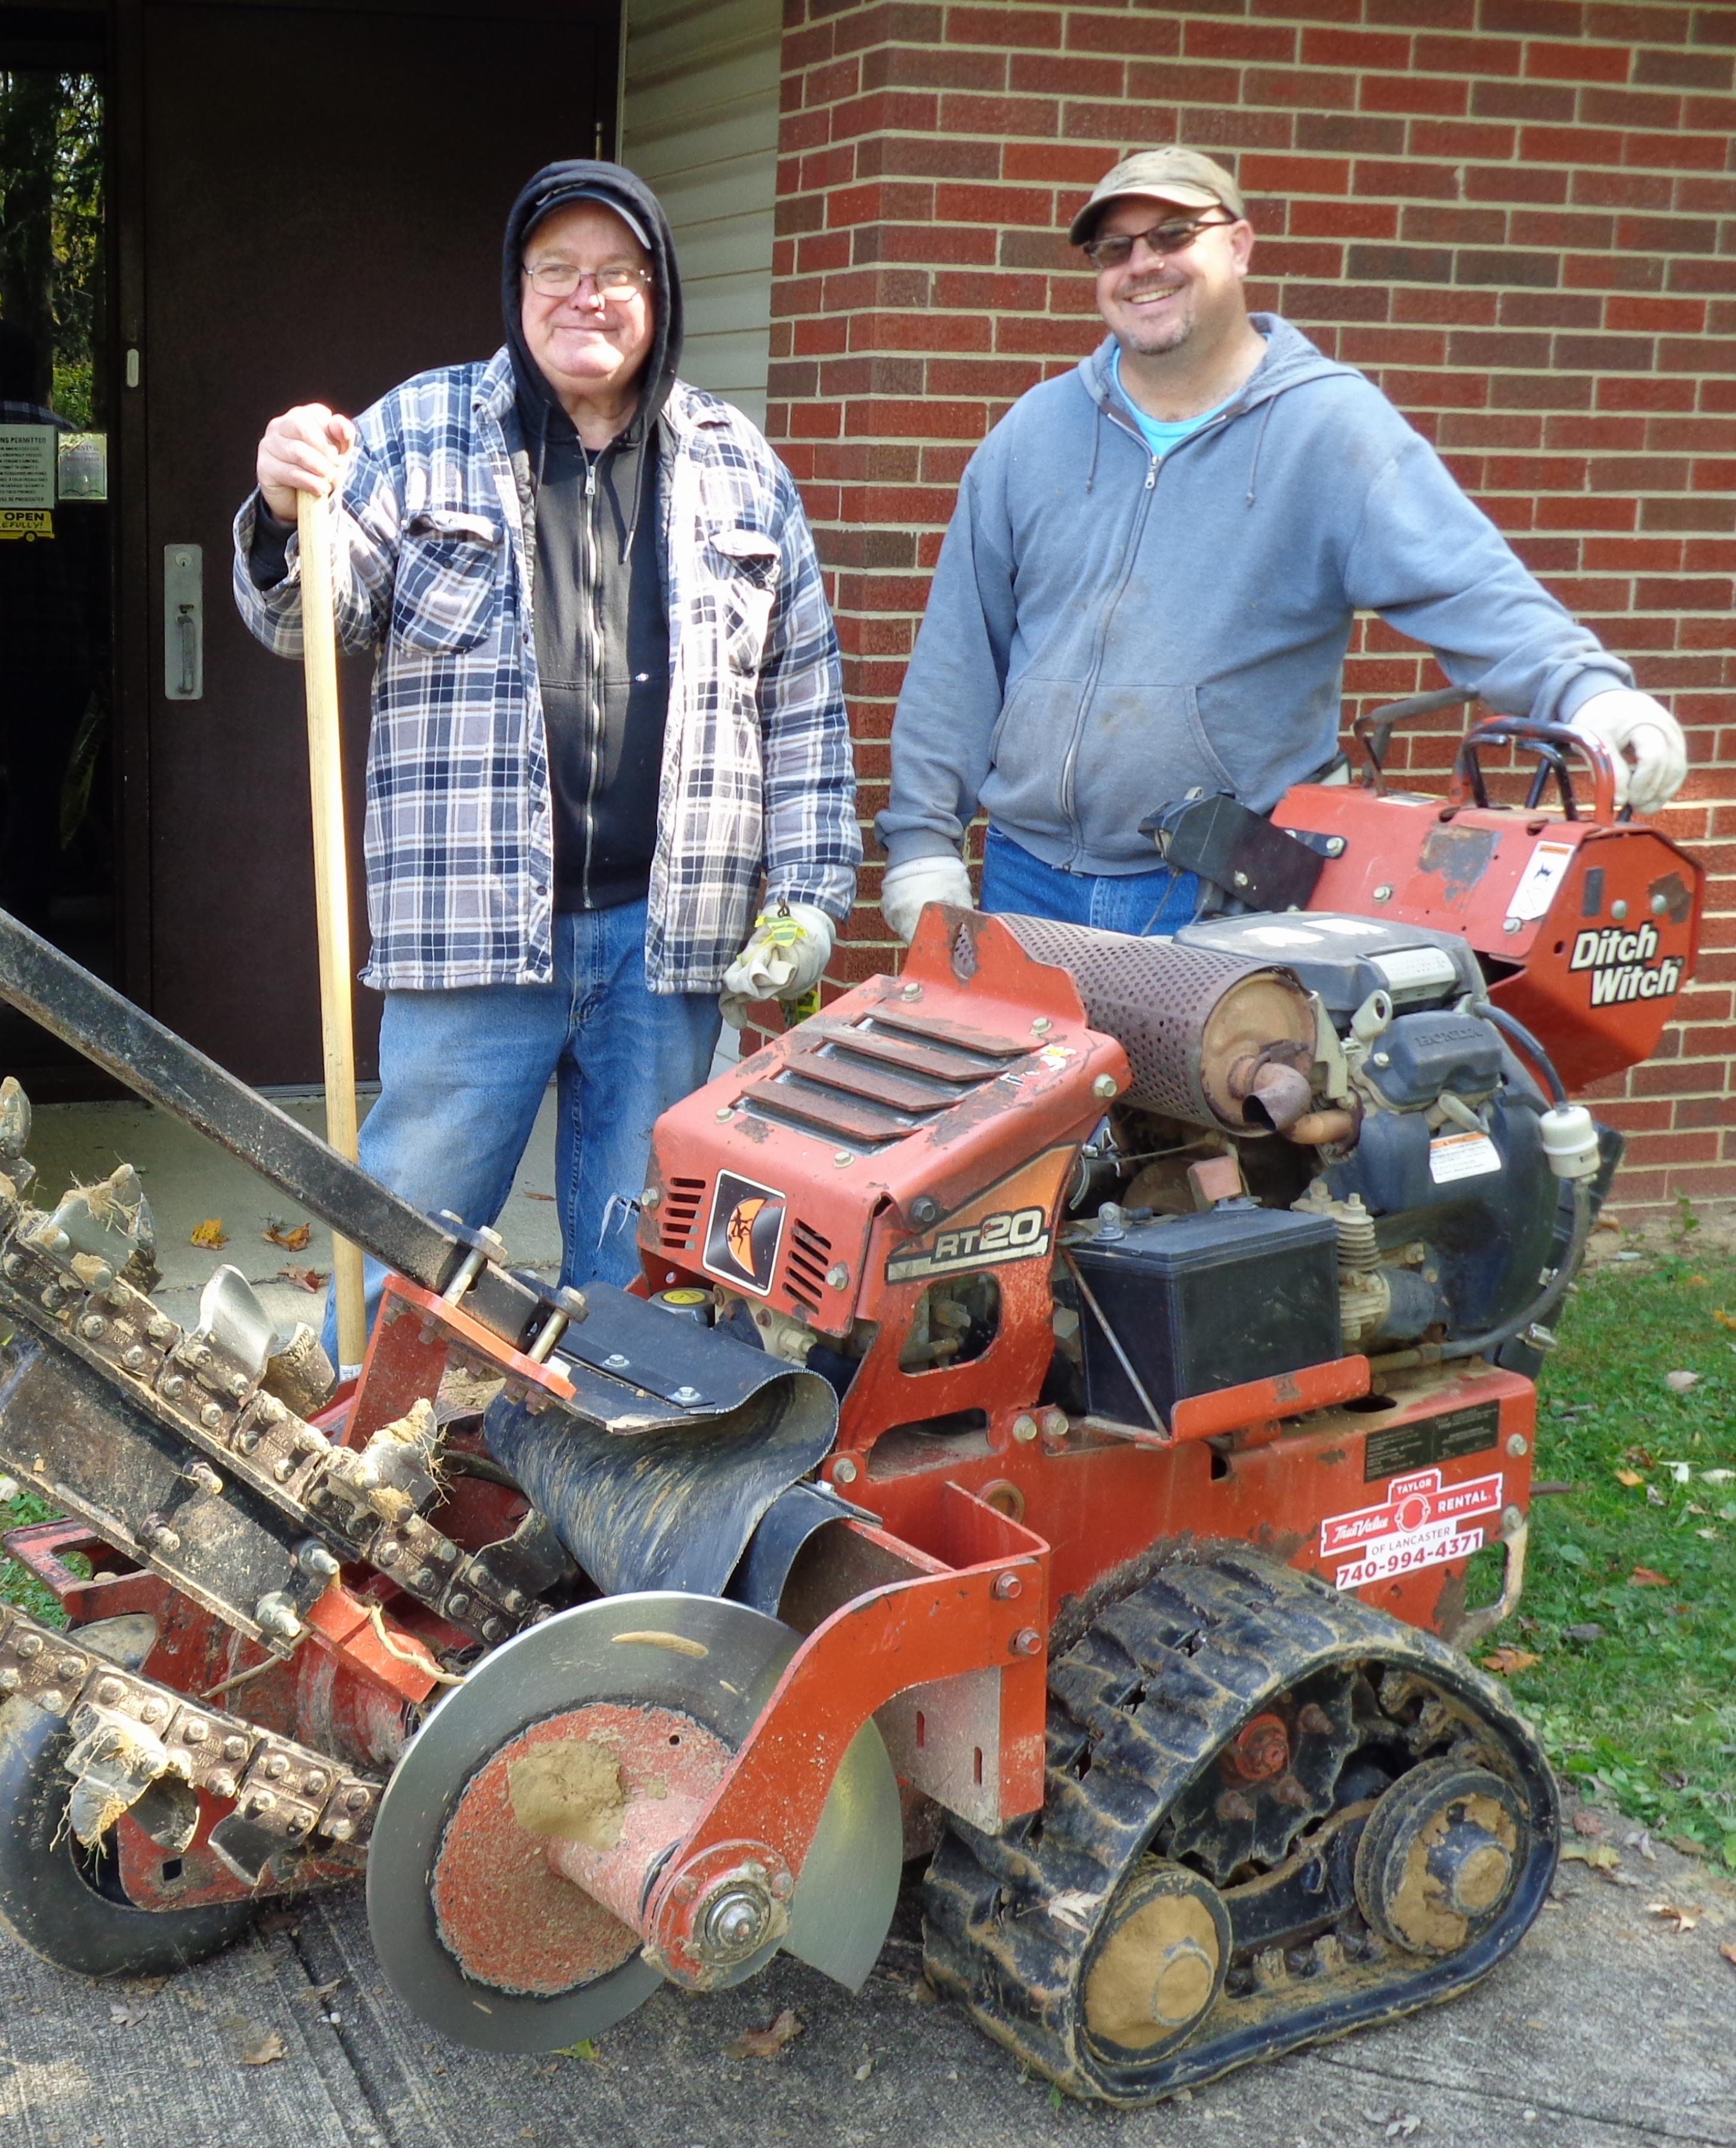
Trenching for the Church Sign Lights Darrell and Anthony
October 6, 2020

