Lancaster Seventh-Day Adventist Church
A House of Prayer for All People

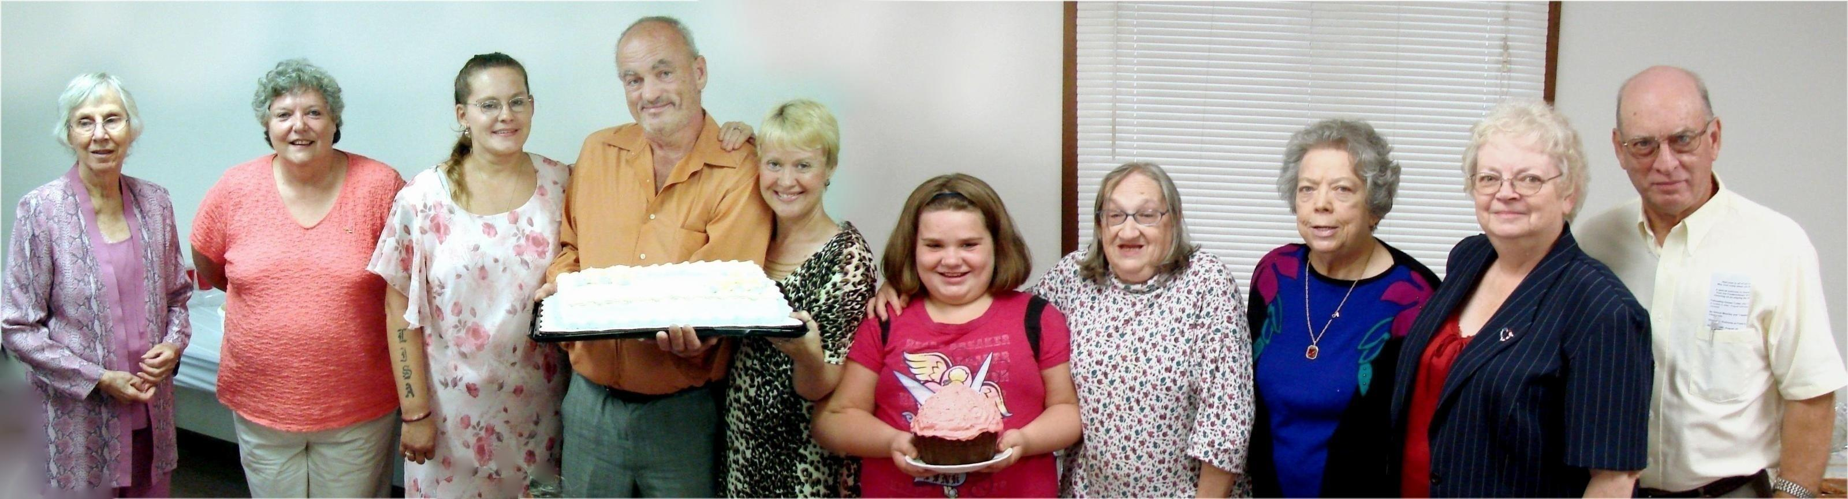

Birthdays: Betty, Nadean, Lisa, Allen, Deena, Brianna, Linda Anniversaries: Josie, Sandy & Howard
August Birthdays and Anniversaries - 2010

