Lancaster Seventh-Day Adventist Church
A House of Prayer for All People

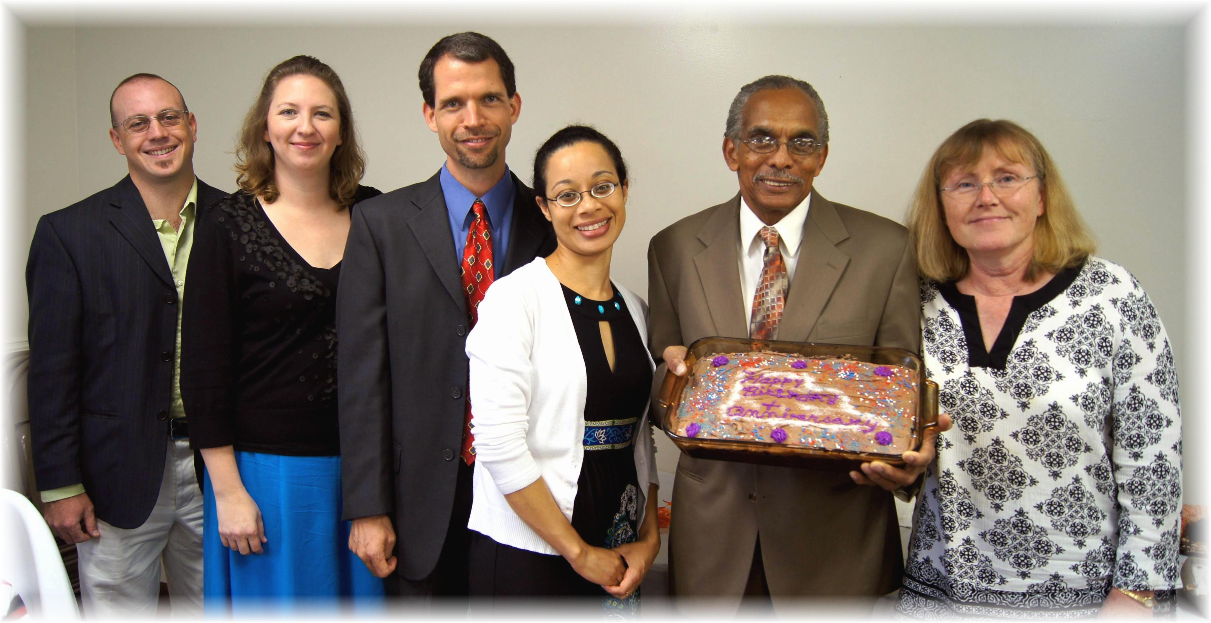
Anthony & Jennifer Southard, Travis & Cesilia Dean, Rick & Christine Wise
September Anniversaries - 2012

