Lancaster Seventh-Day Adventist Church
A House of Prayer for All People

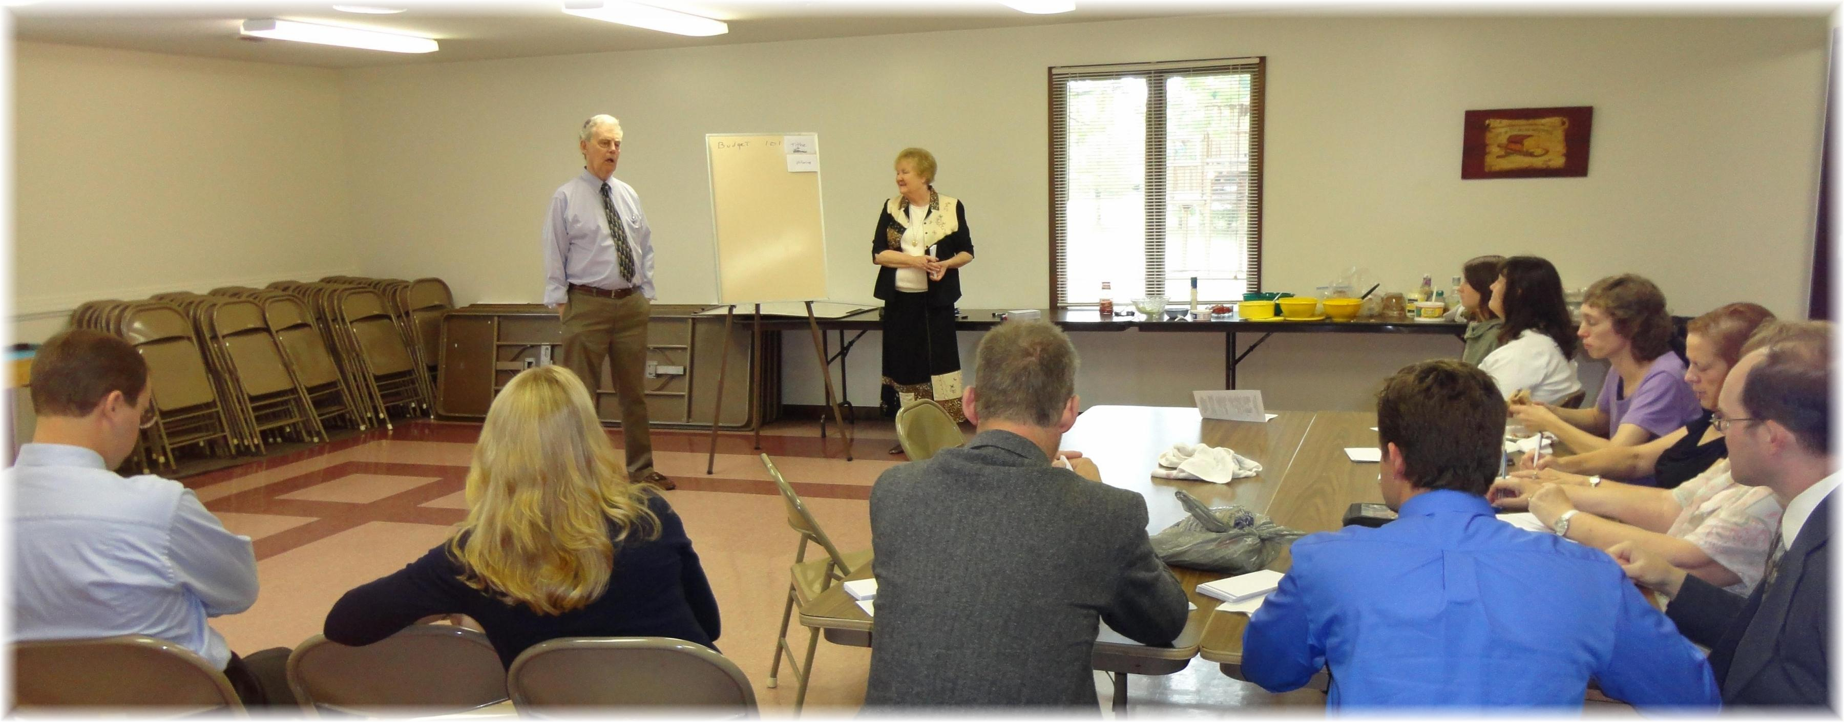

Budget 101 – September 1, 2012

