Lancaster Seventh-Day Adventist Church
A House of Prayer for All People

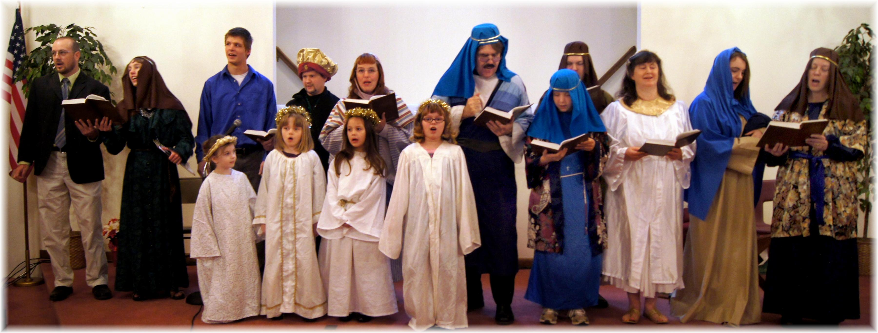
“A Christmas to Believe In”
Skittles Christmas Program - December 15, 2012

