Lancaster Seventh-Day Adventist Church
A House of Prayer for All People

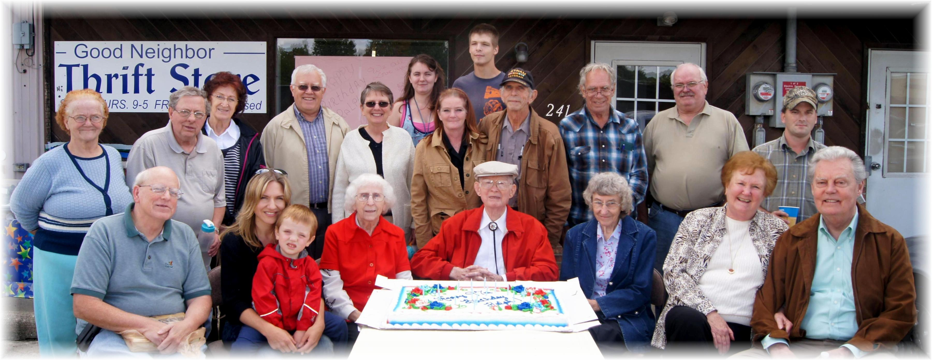
Happy Birthday, Ralph Aldenderfer!
Ralph’s 97th Birthday – September 22, 2013

