**Lancaster Seventh-Day Adventist Church**

**A House of Prayer for All People**

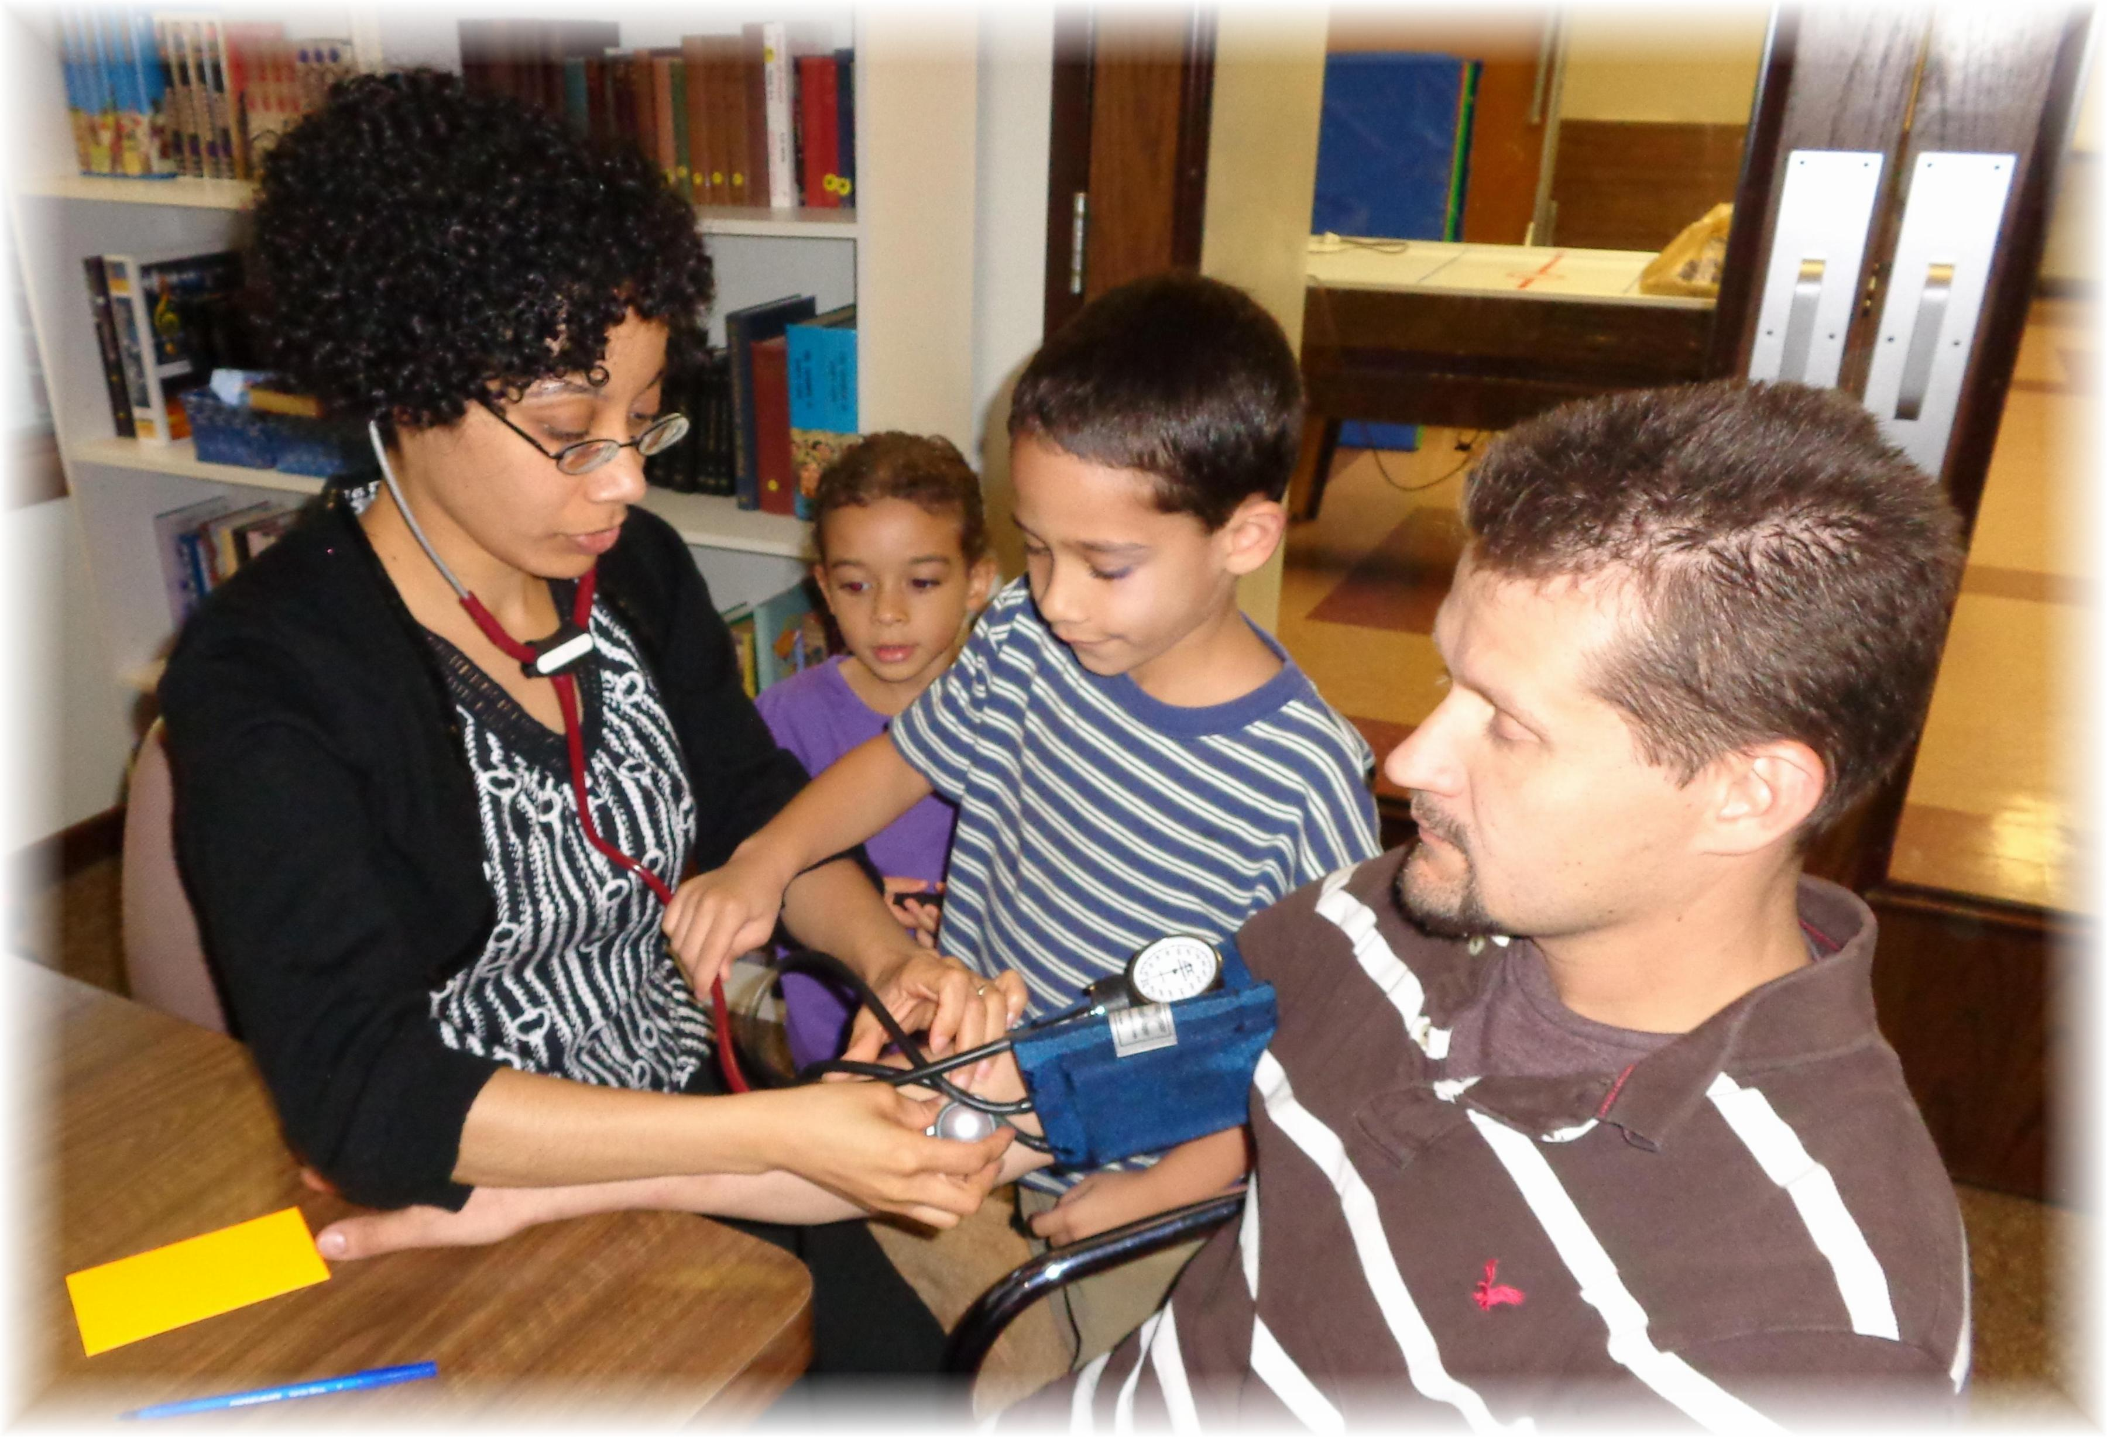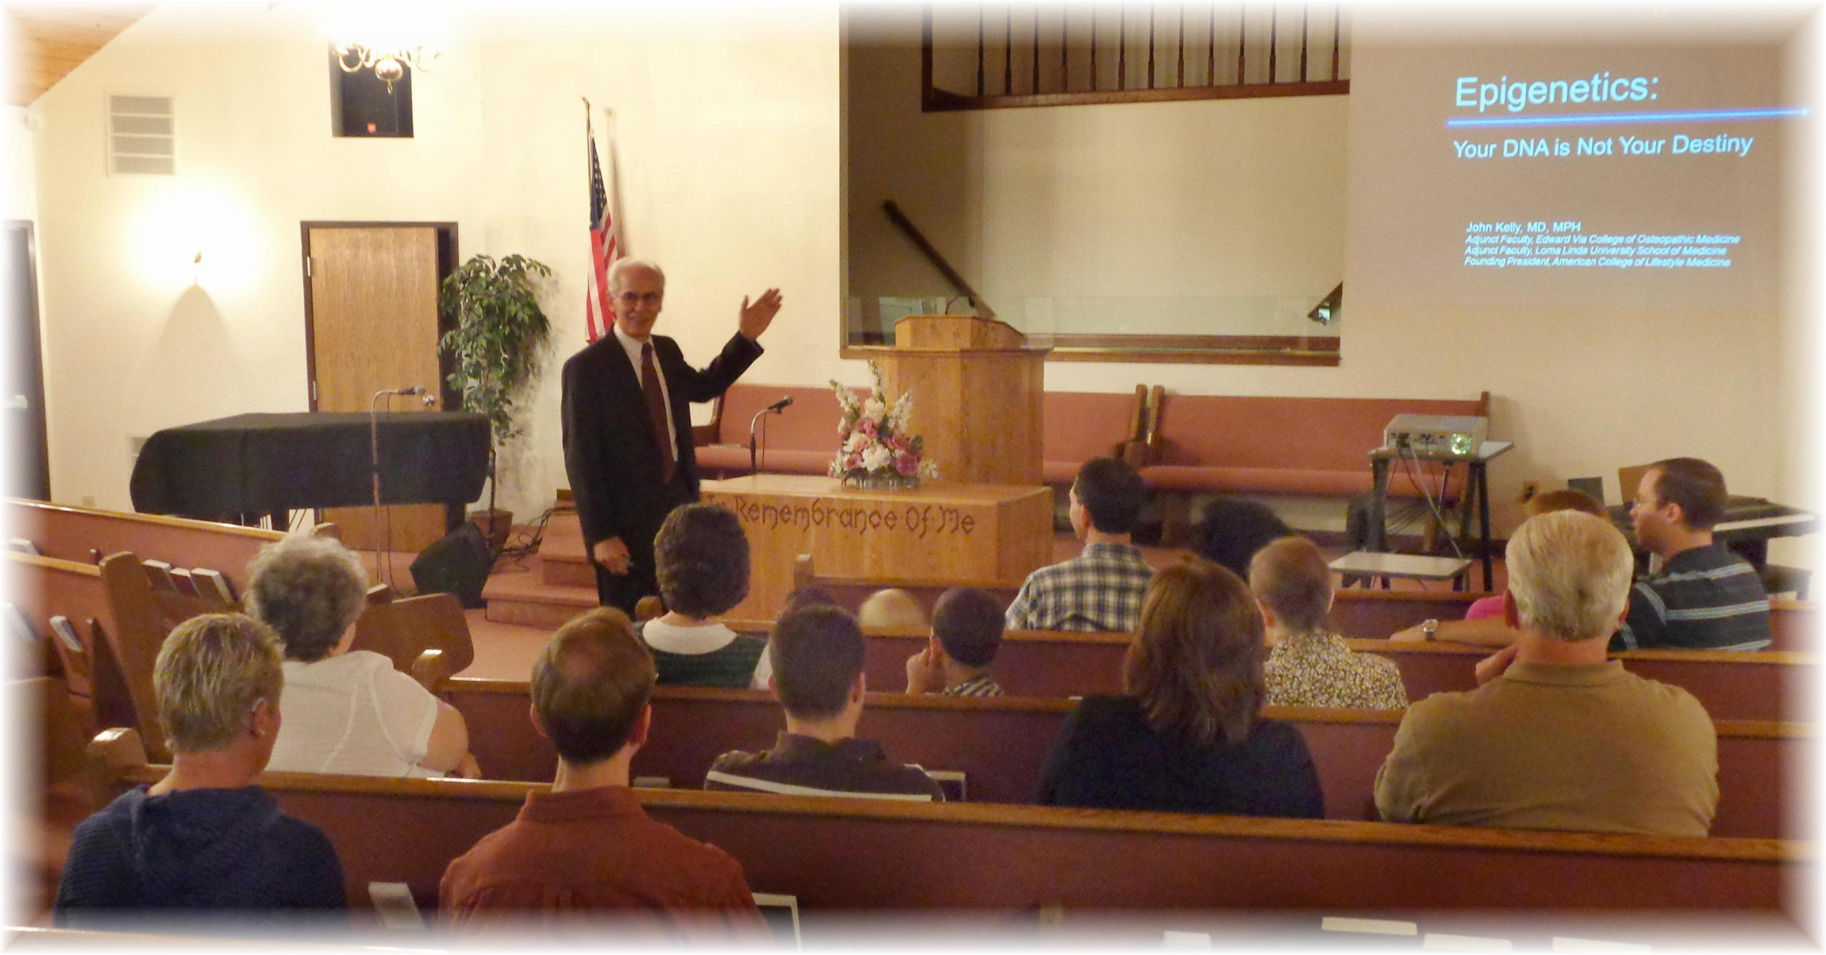

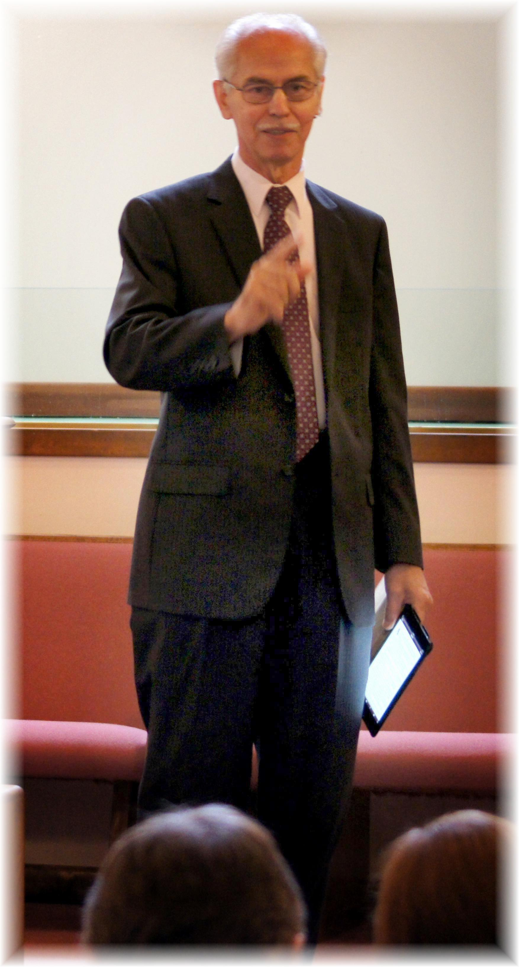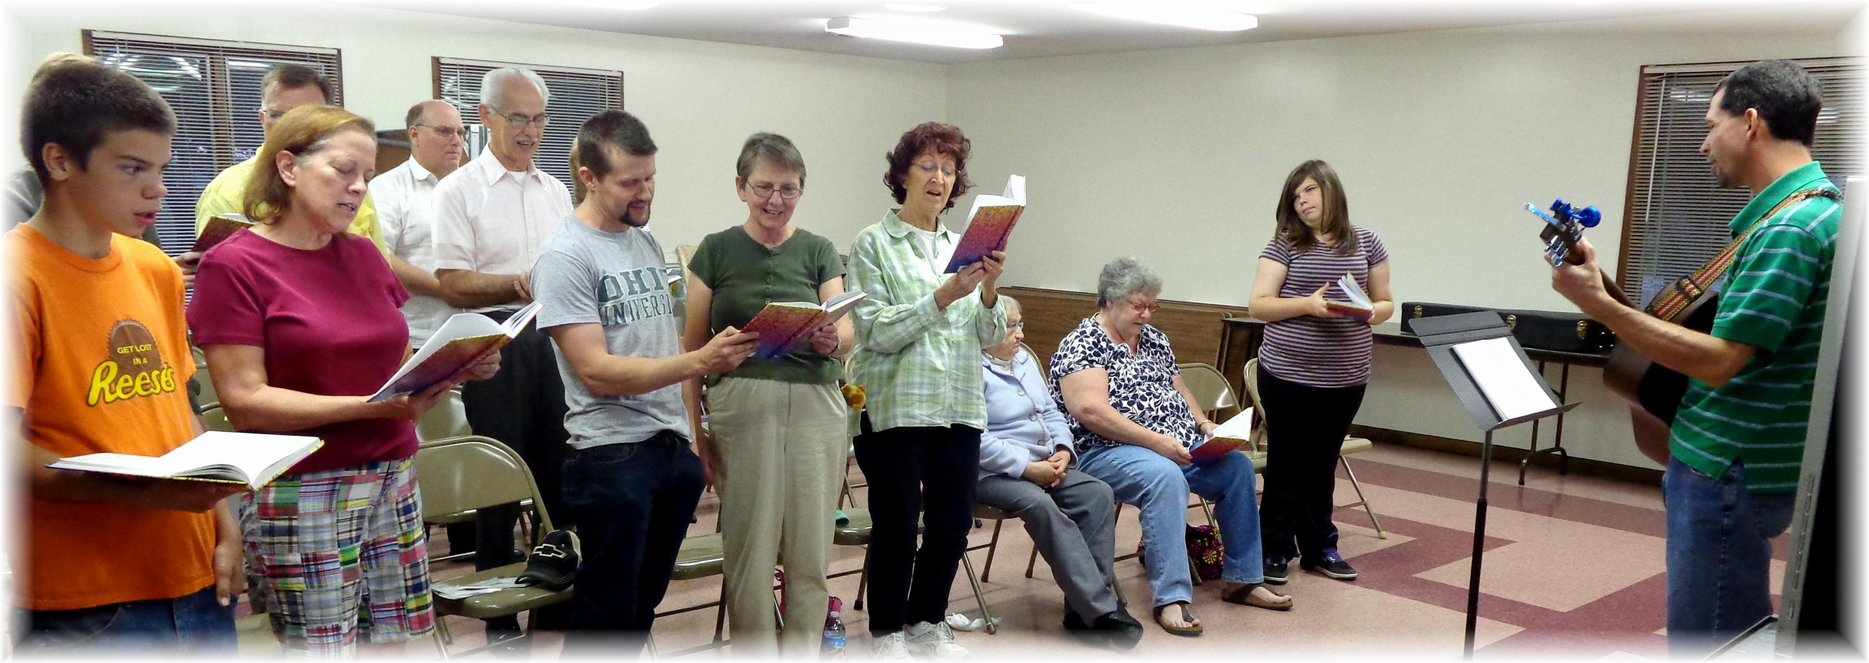

***Health Ministries Weekend – September 27 & 28, 2013***