Lancaster Seventh-Day Adventist Church
A House of Prayer for All People

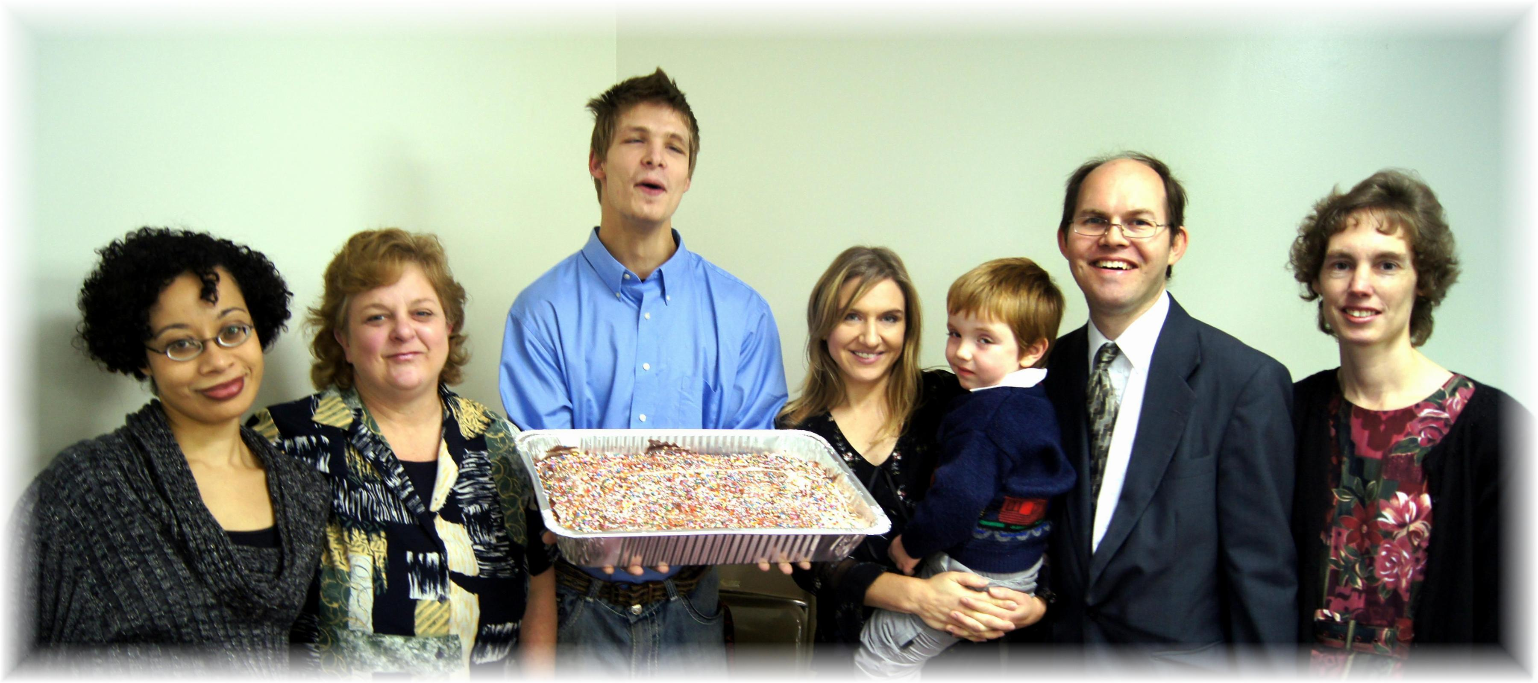
Birthdays: Cesilia, Ronda, Seth, Jesse (with Trina) Anniversary: James & Connie
November Birthdays and Anniversary - 2013

