Lancaster Seventh-Day Adventist Church
A House of Prayer for All People

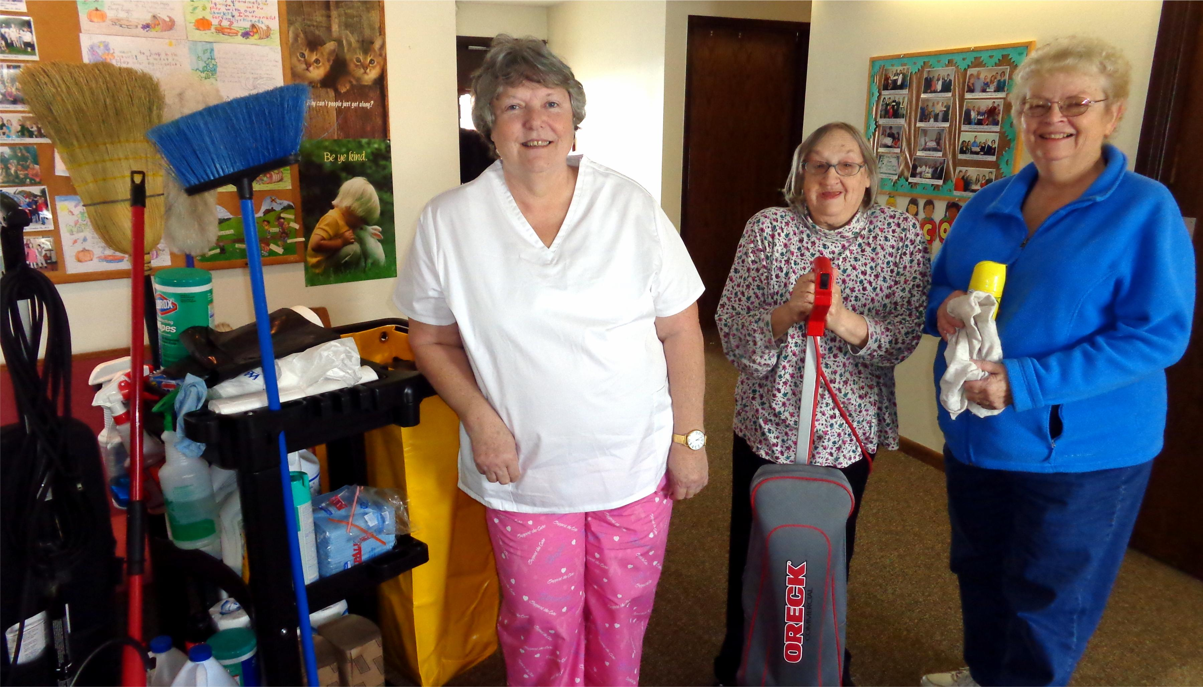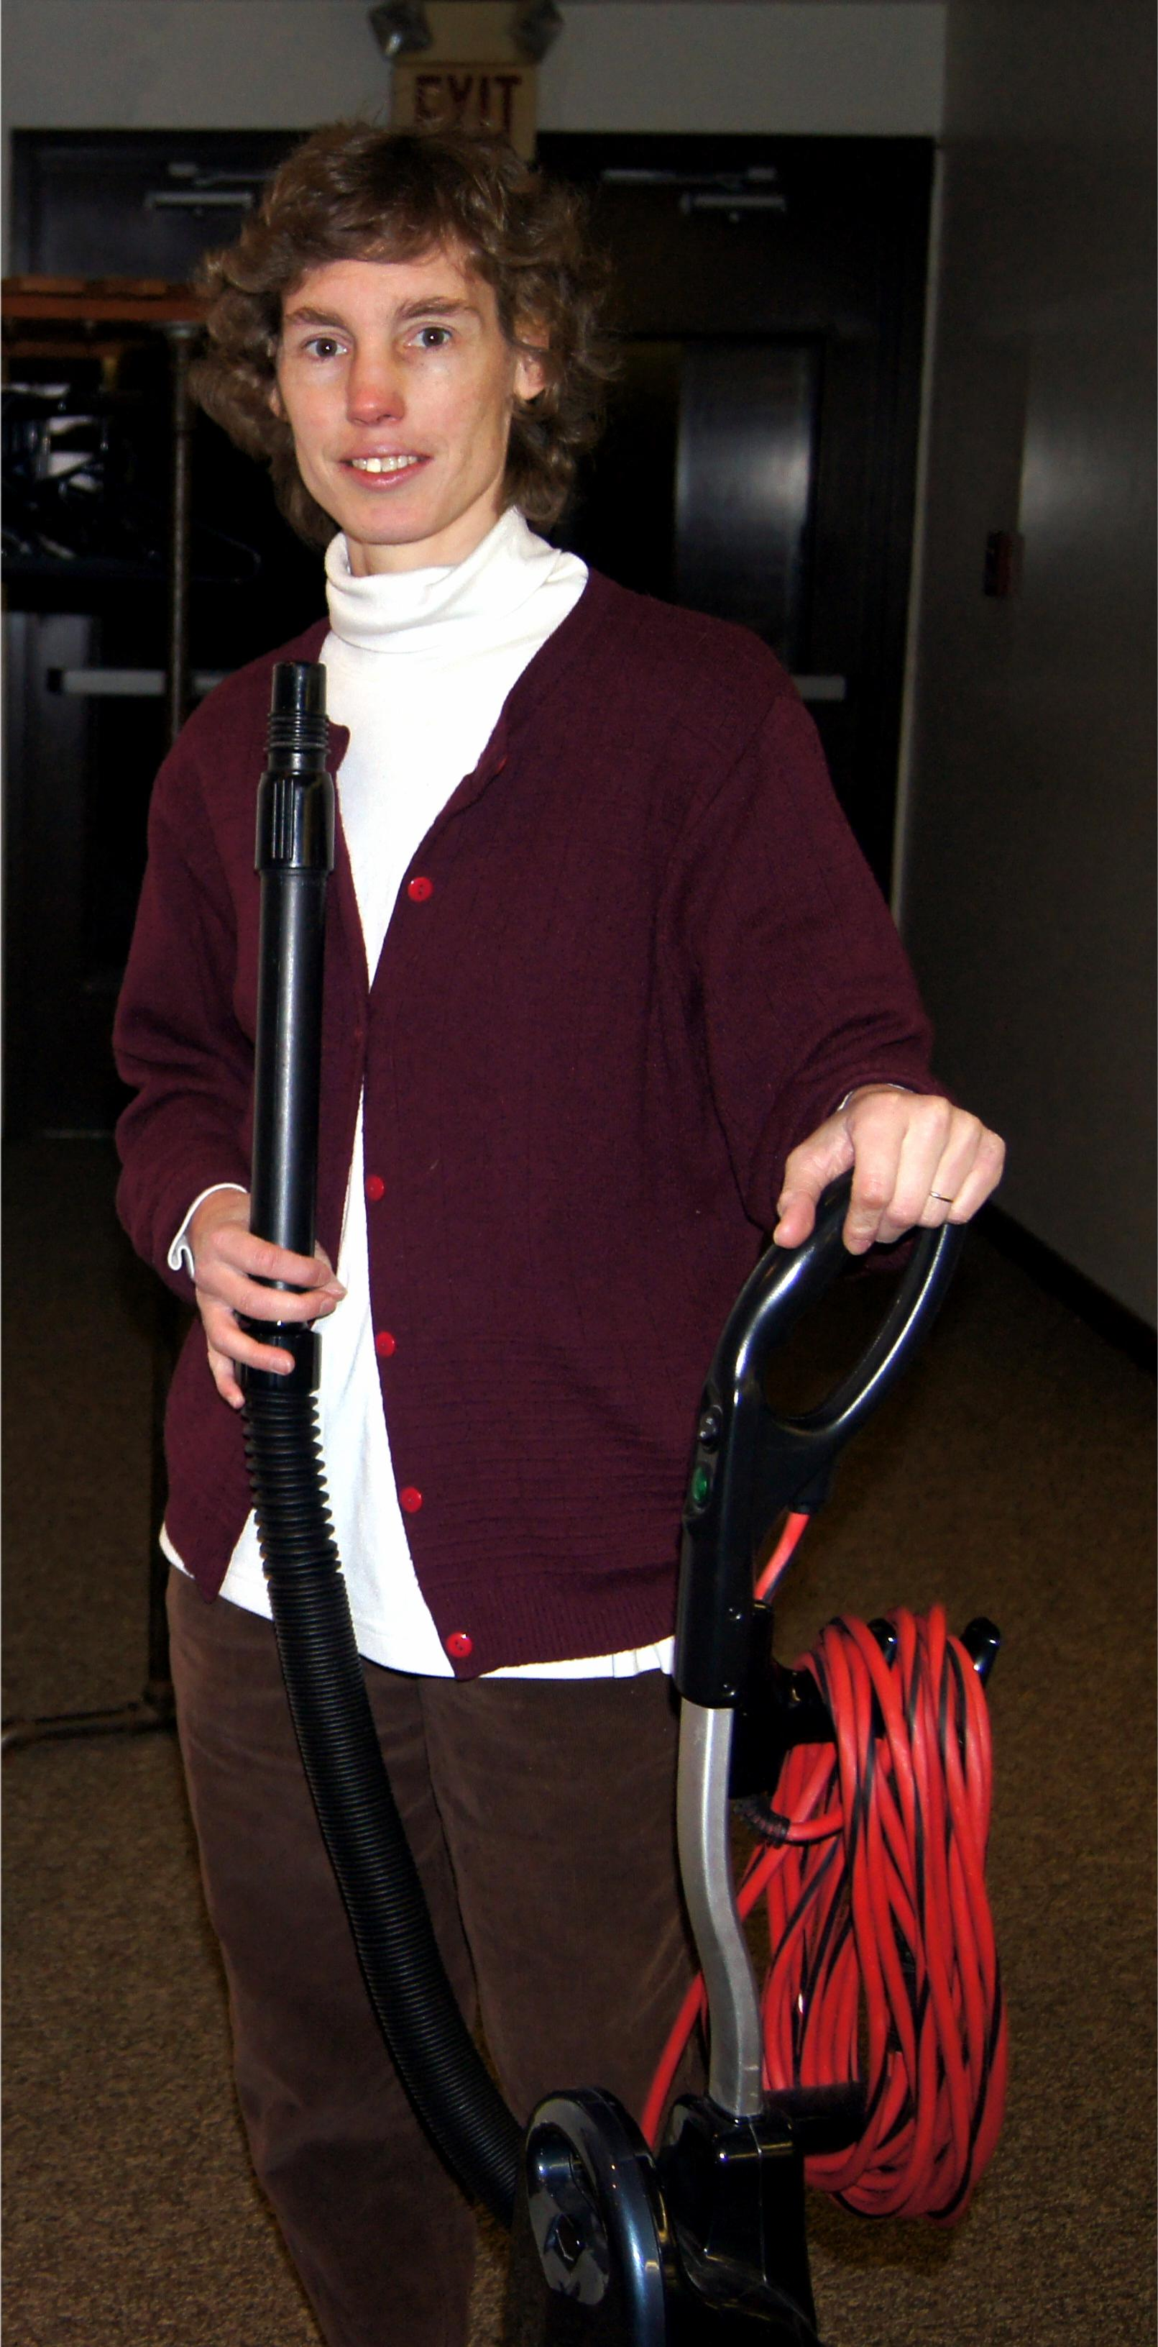
Nadean, Linda, Sandy, Connie
Church Cleaning Crew – 2014

