Lancaster Seventh-Day Adventist Church
A House of Prayer for All People

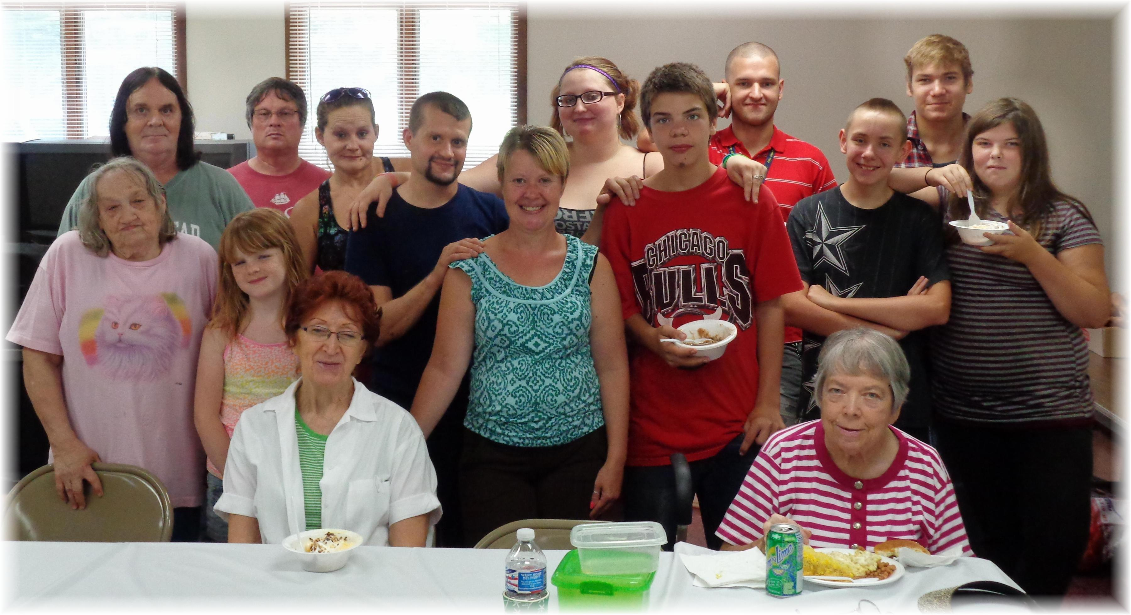
Ice Cream Social ~~ July 13, 2014

