Lancaster Seventh-Day Adventist Church
A House of Prayer for All People

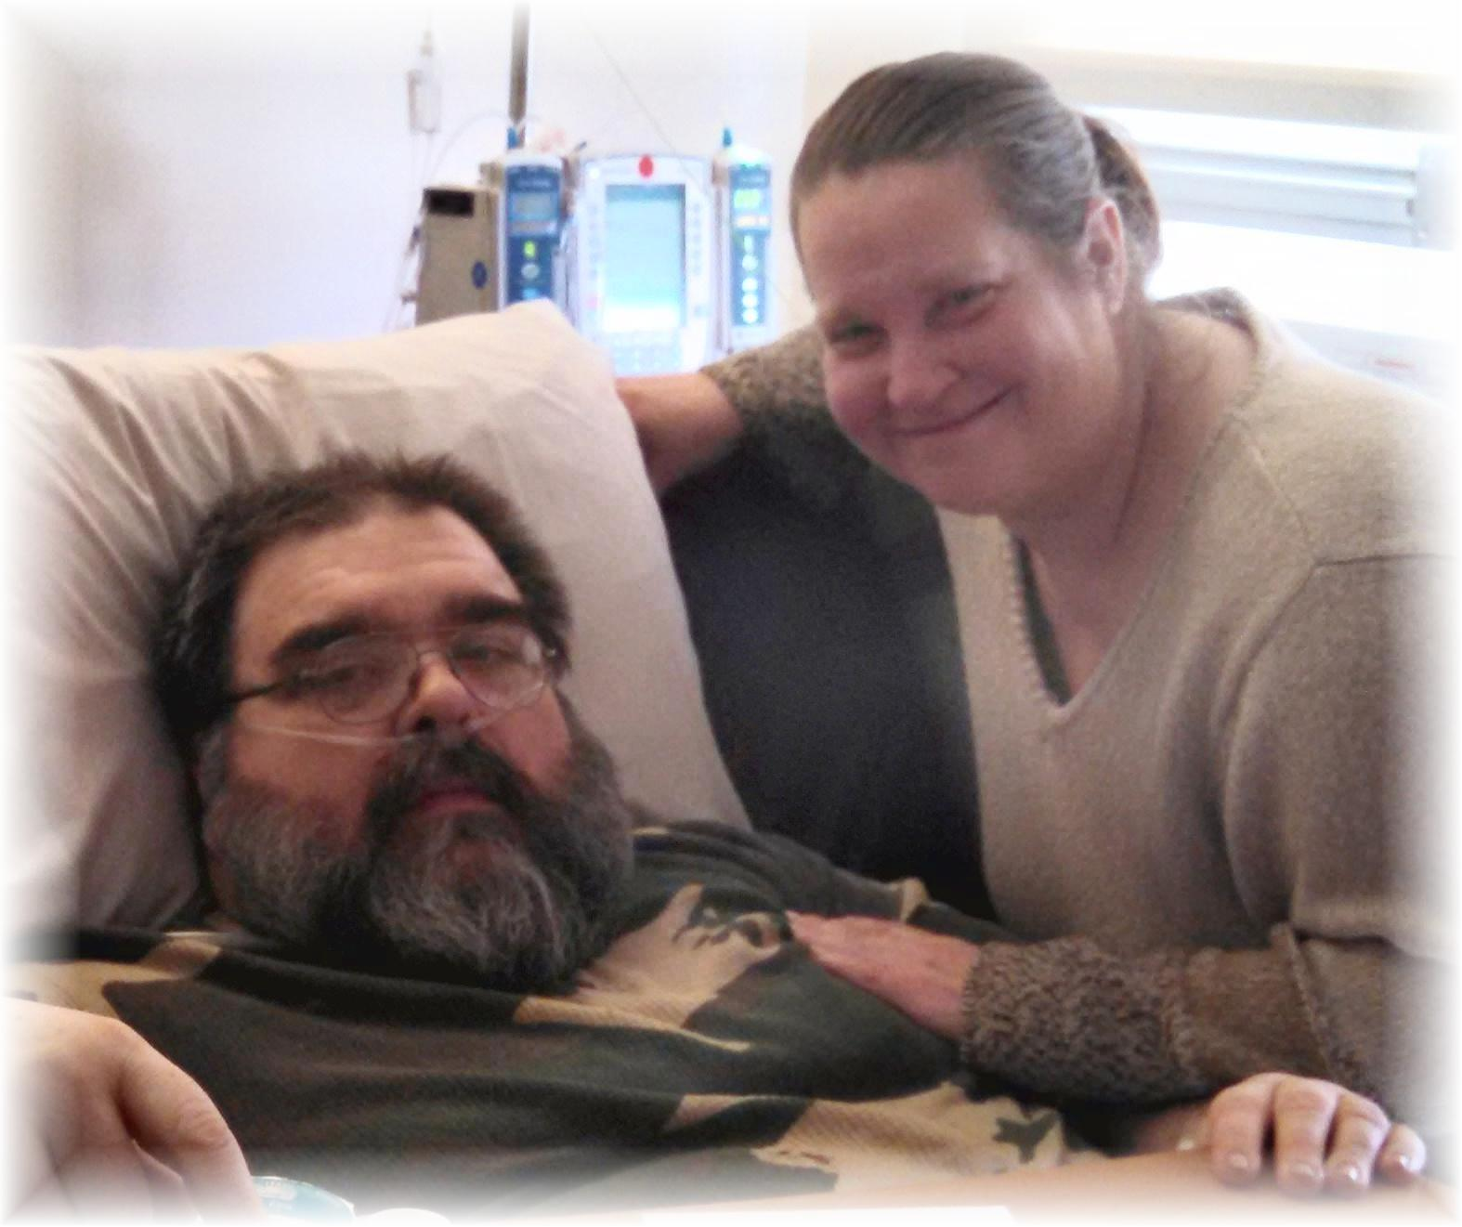
Carlos & Twila Fields - October 2014

